

Topic test 2
Name: __________________________________

Chapter 11 Exponential functions

• Time allowed: 45 minutes
• CAS calculators may be used.
• Part A: 6 multiple-choice questions (6 marks)
• Part B: 7 short answer questions (27 marks)
• Part C: 4 analysis questions (21 marks)
Part A
6 multiple-choice questions
1 mark each: 6 marks
Circle the correct answer.
1 Which of the following equations best corresponds to the graph shown on the right?
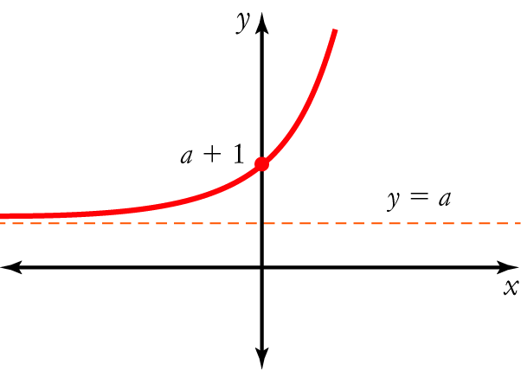
A y = 2x + a
B y = 2x + a
C y = 2(a+1)x + a
D y = (a + 1)22x + a
E y = 2x − a

[1 mark]
Use the graphs below to answer questions 2−4.
A 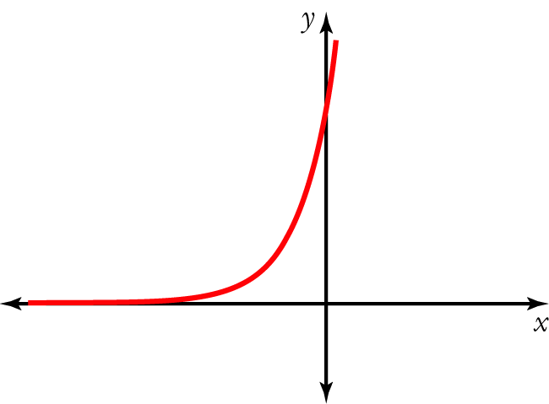 | B  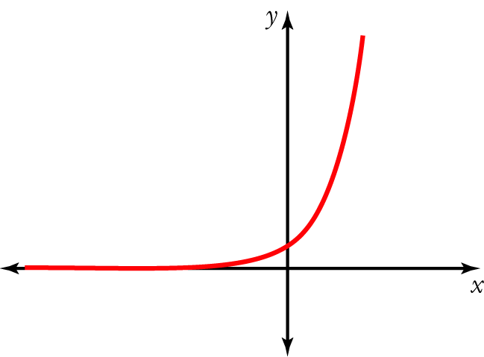 | C  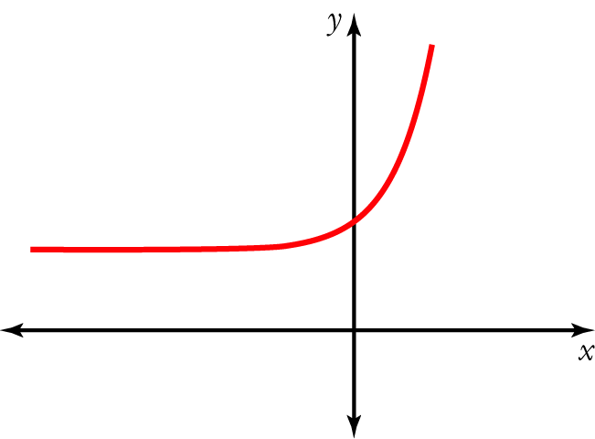
D  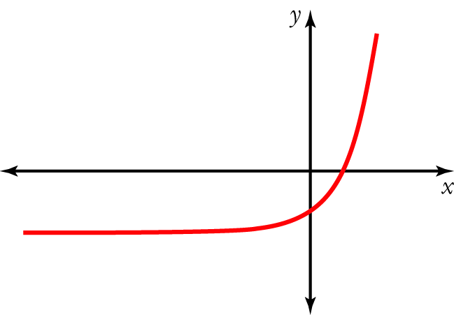 | E  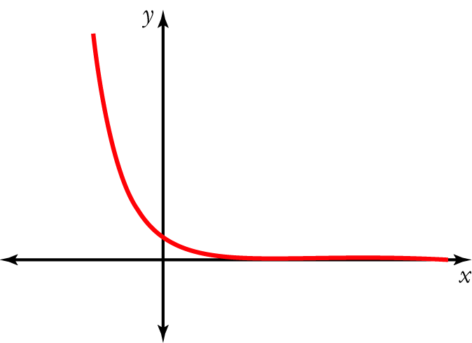
2 Which of the graphs A–E above could represent y = ax + b, where a  1 and b = 0?

[1 mark]
3 Which of the graphs A–E above could represent y = ax1b, where a  1 and b  0?

[1 mark]
4 Which of the graphs A–E above could represent y = ax + b, where a  1 and b  0?

[1 mark]
5 The solution of 3 × 103x+1 = 72 is closest to:
A x = 0.13
B x = 2.07
C x = 1.71
D x = 5.18
E x = 0.46

[1 mark]
6 Which of the following tables shows data from an exponential rule?
A |  |  | B |  |  | C |  |  | D |  |  | E
x | y |  | x | y |  | x | y |  | x | y |  | x | y
0 | 500 |  | 0 | 500 |  | 0 | 500 |  | 0 | 500 |  | 0 | 500
1 | 700 |  | 1 | 400 |  | 1 | 400 |  | 1 | 600 |  | 1 | 350
2 | 1000 |  | 2 | 320 |  | 2 | 300 |  | 2 | 700 |  | 2 | 250
3 | 1400 |  | 3 | 256 |  | 3 | 200 |  | 3 | 800 |  | 3 | 200

[1 mark]
Part B
7 short answer questions
27 marks
Show your working where appropriate.
1 Evaluate 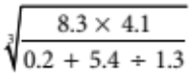, correct to 3 significant figures.

[2 marks]
2 Simplify and express with positive indices.

a 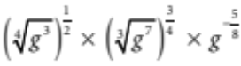

b 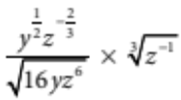

[6 marks]
3 g(h) = 2.4 × (0.8)h − 5. Find the value of:
a g(4)

b g(−2)

[2 marks]
4 Solve the following equations.
a 9x−5 = 243

b 53−2x − 125 = 0

c 49 − 3432x+3 = 0

[9 marks]
5 The graph of y = 2x is shown. Use the graph to solve 2x = 3
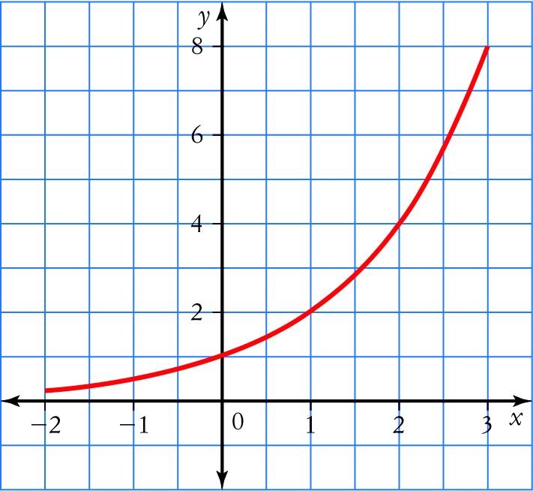
[2 marks]
6 Use a graph drawn with a graphics calculator to solve 5x = 16.

[2 marks]
7 For each of the following exponential functions, calculate the y-intercept and the equation of
the horizontal asymptote.
a y = 3 × 5(x−1)

b y = 6 × 1.4(x−2) + 4

[4 marks]
Part C
4 analysis questions
21 marks
Show your working where appropriate.
1 Sketch the graph of each of the following by first determining the key features of the graph.
a y = 5x − 4

b y = 3x+2 + 2

[6 marks]
2 Sketch the graph of y = 3x−4 + 3 by transforming the graph of y = 3x.

[4 marks]
3 The size of a fungus doubles every day from an initial mass of 0.04 g.
a Set up an exponential model of the mass of the fungus.

b Find the mass of the fungus after:
i 3 days ____________________
ii 10 days ____________________
iii 25 days ____________________
c Find the time taken for the mass to reach 500 g.

[6 marks]
4 A sample of radioactive material loses 4% of its radioactivity per annum.
Calculate the half-life of the material.

[5 marks]
Total marks: 54
Answers
Part A [1 mark each]
1 The graph is the same as y = 2x but translated a units up. This would be y = 2x + a.
 B [1 mark]
2 The graph of y = ax + b will look like the graph of y = ax (where a  1) because b = 0.
 B [1 mark]
3 The graph of y = ax1b will look like the graph of y = ax (where a  1) that has been translated
b units to the left because b  0.
 A [1 mark]
4 The graph of y = ax + b will look like the graph of y = ax (where a  1) that has been translated
b units down because b < 0.
 D [1 mark]
5 The equation can be simplified to 103x11 = 24. Since 24 is between 101 and 102, 3x + 1 must lie
between 1 and 2. In other words, 1 < 3x +1 < 2. This can be simplified to 0 < 3x < 1 and
0 < x < . The only choice that meets this criteria is A.
 A [1 mark]
6 For the rule to be exponential, the quotient of successive terms must be constant. This is only
true for B.
[ B [1 mark]
Part B
1 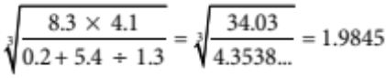…  1.98 [2 marks]
2 a 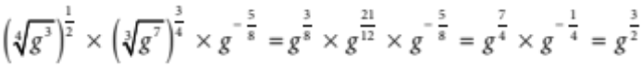 [3 marks]
b 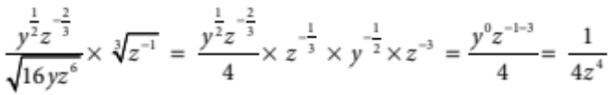 [3 marks]
[6 marks]
3 a g(4) = 2.4 × (0.8)4 − 5  −4.0170 [1 mark]
b g(−2) = 2.4 × (0.8)22 − 5  −1.25 [1 mark]
[2 marks]
4 a 9x−5 = 243 32(x−5) = 35 [1 mark]
2x − 10 = 5 x = 7 [2 marks]
b 53−2x − 125 = 0 53−2x −53 = 0 [1 mark]
3 − 2x = 3 x = 0 [2 marks]
c 49 − 3432x+3 = 0 72 − 73(2x+3) = 0 [1 mark]
2 = 6x + 9 x = −1 [2 marks]
[9 marks]
5 Locate the point on the graph where y = 3.
Draw a vertical line to intersect the x-axis and read the value of x.
x  1.6
[2 marks]
6 Draw the graph. Use the trace function or locate the zero of 5x − 16 = 0.
x  1.723 [2 marks]
7 a Let x = 0: y = 3 × 5−1 = 0.6
y-intercept = 0.6 [1 mark]
Compare with y = Aax + B + C : C = 0, so horizontal asymptote is y = 0 [1 mark]
b Let x = 0: y = 6 × 1.4(1 − 2) + 4 = 7.06
y-intercept = 7.06 [1 mark]
Compare with y = Aax + B + C : C = 4, so horizontal asymptote is y = 4 [1 mark]
[4 marks]
Part C
1 a 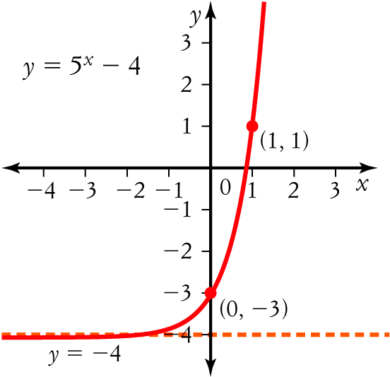
[3 marks]
b 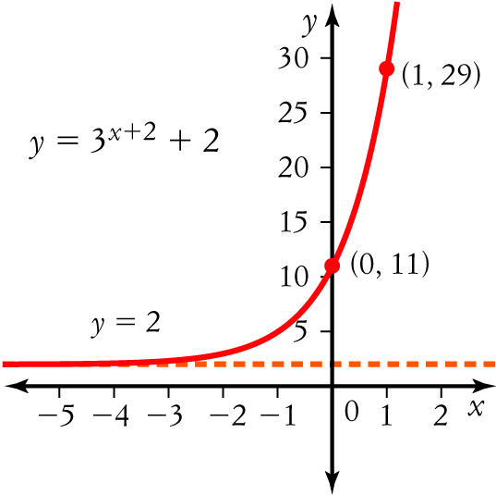
[3 marks]
[6 marks]
2 Compare y = 3x−4 + 3 with y = ax+B − C. B = −4 and C = 3. [1 mark]
Plot the graph of y = 3x. Slide the graph 4 units to the right and then slide the graph 3 units up. [1 mark]
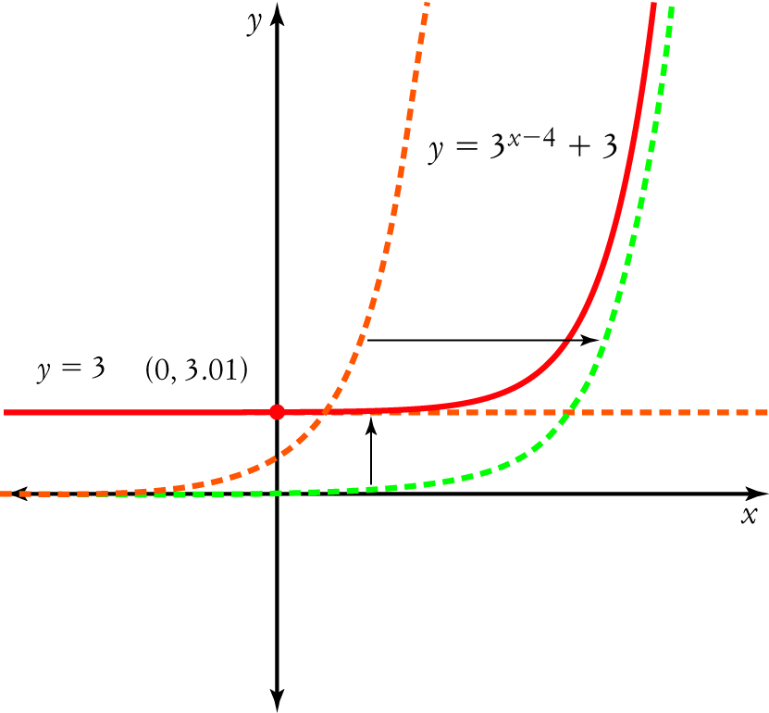 [2 marks]
[4 marks]
3 a Growth rate = 2; initial value = 0.04. Let d = number of days. [1 mark]
F = 0.04 × 2d [1 mark]
b i F = 0.04 × 23 = 0.32 g [1 mark]
ii F = 0.04 × 210 = 40.96 g [1 mark]
iii F = 0.04 × 225 = 1 342 177 g [1 mark]
c 500 = 0.04 × 2d
2d = 12 500 [1 mark]
Use trial and error to solve for d, or use the solve() function on your CAS calculator.
d  13.6 days [1 mark]
[6 marks]
4 Growth factor = (100 − 4)% = 0.96; initial value = a [1 mark]
Let y = number of years
Let R = radioactivity
R = a × 0.96y [1 mark]
At half-life, R = a [1 mark]
a = a × 0.96y
= 0.96y [1 mark]
Use trial and error to solve for y, or use the solve() function on your CAS calculator.
y  16.98 years [1 mark]
[5 marks]

